Abstract of Weather Data Analysis case study:
As part of this case study considered the 2 csv file daily_precipitation_details and monthly_precipitation_details which are placed in data folder. As part of the implementation logic , we are creating the tables dynamically when you run the application and the information is stored in the database tables. when the user want to query any of those tables, he can simple enter his question in the text box “enter your Question in the natural language and when he click on the execute button the application will generate the sql query dynamically based on the users request and populate the results as shown in the below screen shot. Supporting framework to implement the application
- Python – application logic implementation
- Streamlit – User Interface
- Google LLM– to convert natural language to sql query
- Mysql Database – for storing the daily and monthly precipitation details

Attached the below screenshots for your reference.
Note: DB configuration details in config file and Google key in env file are not included are not included in the attached zip file.
Query: Compare the precipitation amount of tamil nadu and karnataka in Nov 2006 in a table format.

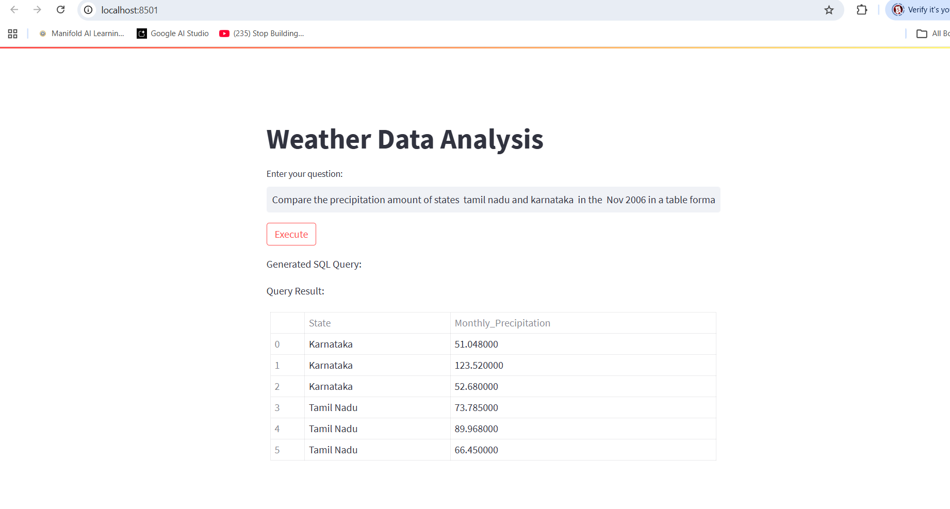

Query : what is the total precipitation amount of Thiruvananthapuram in each august and September from the year 2001 to 2005.
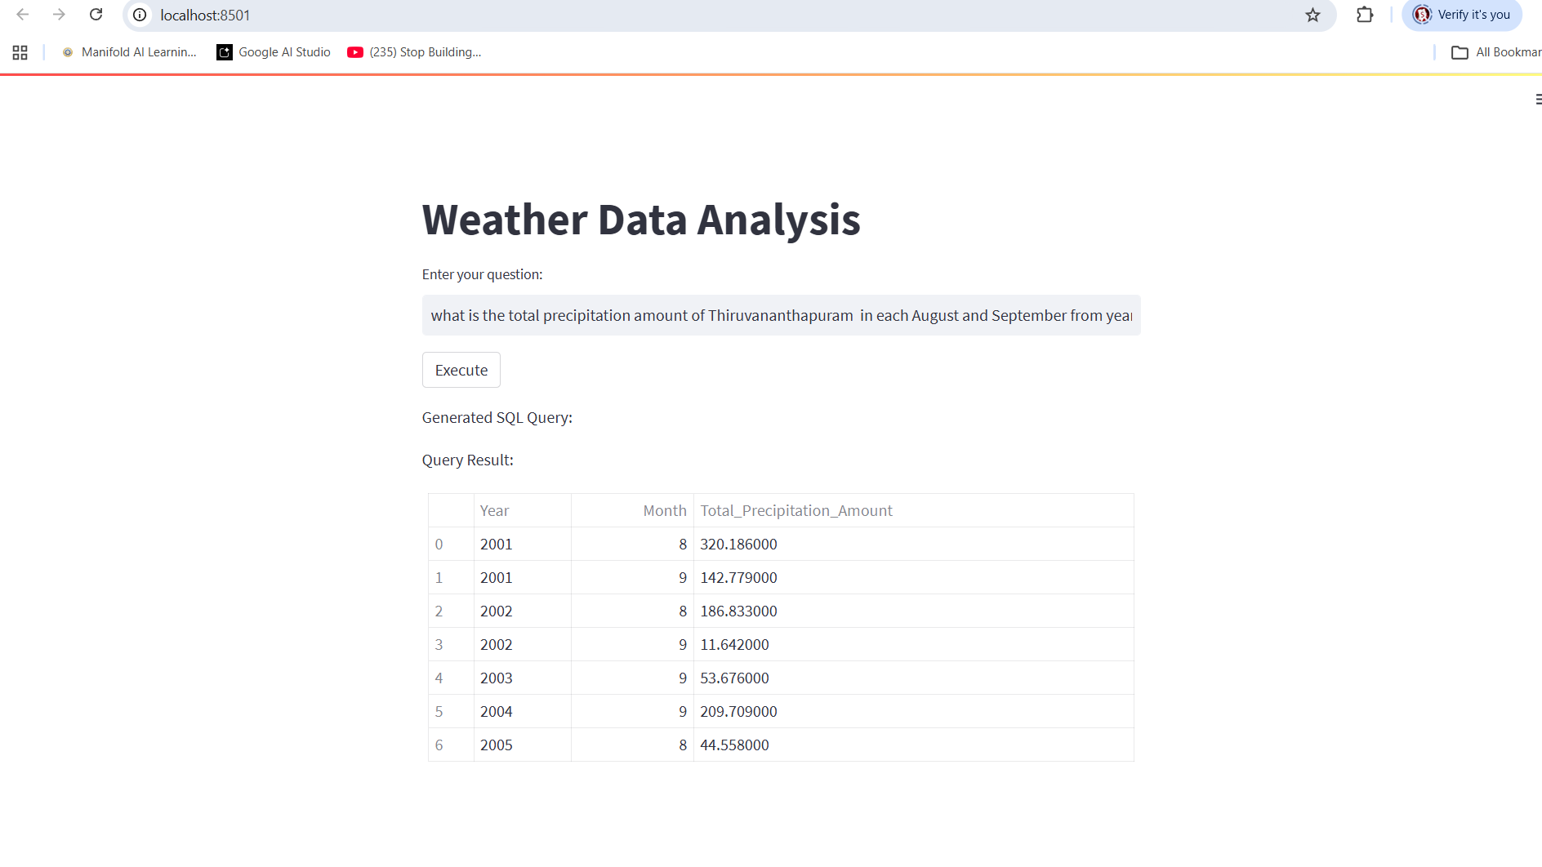
Query : what is the total precipitation amount of Andhra Pradesh in each august and September from the year 2001 to 2005.
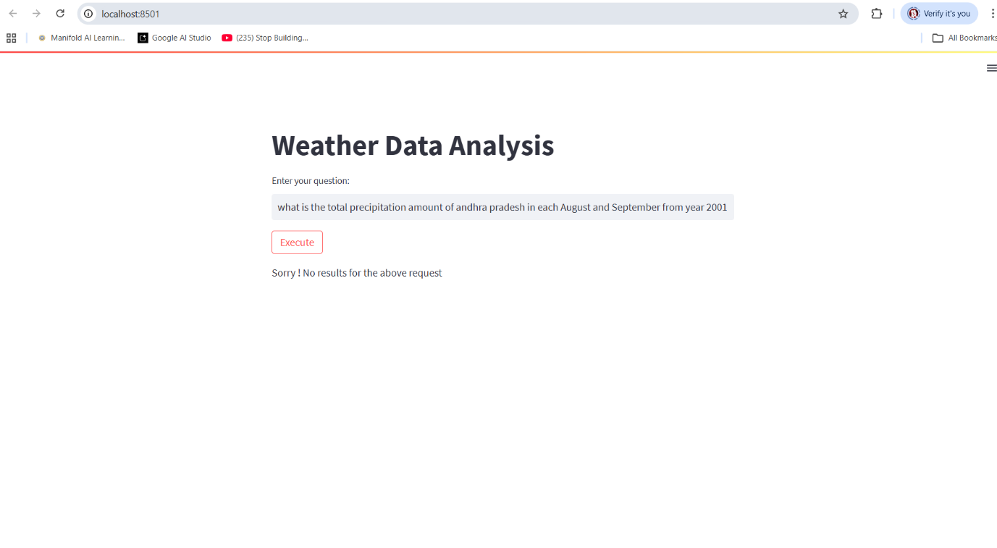

Query :

